Professor Clint Sprott
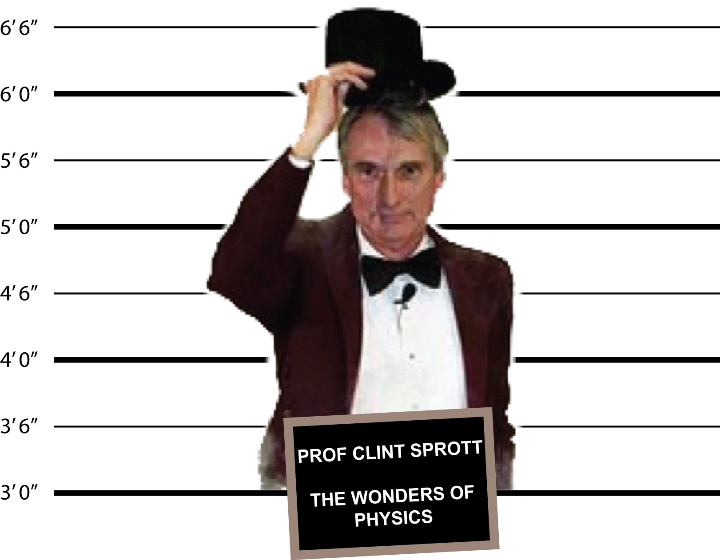
Born in Memphis, Tennessee in 1942, Clint Sprott developed an interest in physics early in his childhood. He went on to earn a B.S. at the Massachusetts Institute of Technology in 1964 and a Ph.D. in physics at the University of Wisconsin in 1969. He spent 1970-1972 at the Oak Ridge National Laboratory in Tennessee. Then in 1973 he returned to the University of Wisconsin – Madison to become Professor of Physics. His research is in plasma physics and chaos, and he is currently working on complex nonlinear dynamical systems.
In an effort to share with the public his lifelong interest and enthusiasm for physics, Professor Sprott has presented “The Wonders of Physics” since 1984.

Acknowledgements
Thanks to all who helped put this program together.
A special thanks to the following:
Adam Blonsky Joe Dickenson? Tara Keenan
Jim Latimer Ed Leonard Marty Lichtman
Aryka Narf Steve Narf Paul Nonn
Mike Randall Dale Schutte Zane Shahrani
Peter Weix Michael Winokur Bill Young
Bill Zimmerman
Sponsors and Donors
US Department of Energy
National Science Foundation

Thanks for Coming!
THE LAWS OF PHYSICS
The 32nd Annual Presentation of
The Wonders of Physics

featuring
Professor Clint Sprott
And The UW Physics Department
2103 Chamberlin Hall • 1150 University Ave.
University of Wisconsin – Madison
2015

The Laws of Physics
Professor Sprott has been accused of breaking the laws of physics! Is that possible? If not, how can physicists explain the seemingly impossible things that happen in some experiments? Join Professor Sprott and the UW-Madison Physics Crew as they unravel this mystery!

PROGRAM
Prologue (Marty Lightman, Peter Weix, Clint Sprott)
Motion (Steph Kubala):
Non-Newtonian fluid
Bead chain syphon
Stack of cards
Double cone on rails
Faster than “g” stick
Heat (Ed Leonard):
Boiling water with ice
Freezing by evaporation
Leidenfrost Effect
Liquid nitrogen cannon*
Sound (Akire Trestrail):
Ultrasound
Oscilloscope waveforms
Range of hearing
Ultrasonic levitation
Electricity (Mike Randall):
Ohm’s Law board
Electric pickle
States of matter
Plasma ball
Musical Tesla Coil*
Magnetism / E&M (Andrew Seltzman):
Lorentz force
Superconductor levitation
Induction heating
Microwaves
*Please note that these demonstrations will produce a loud and/or sudden sound.
Educational materials and special presentations of “The Wonders of Physics” are available for schools and other groups. Please visit: http://wonders.physics.wisc.edu/ for more information.
Presentations from 1986 to the present are available on DVD and the Web. Call 608-262-2927 or visit sprott.physics.wisc.edu/wop.htm for details.
Please give us your comments about “The Wonders of Physics” at sprott.physics.wisc.edu/wop/survey.htm.
Your donations to the “UW Wonders of Physics Fund” will help us to continue these presentations. To make a donation please visit
http://wonders.physics.wisc.edu/228.htm
Thank you!
Coordinator: Peter Weix
Visuals & Sound Effects: Steve Narf
Lighting: Bill Zimmerman
Theme Music: Jim Latimer &
Frank Ferriano
Magnetism (Michael Winokur):
Oersted Effect
Ferrofluid
Lenz’s Law
Can crusher*
Levitated ball
Light (Marty Lichtman):
Spiral light pipe
Water light guide
Rainbow
Twinkling stars
Speed of light
Epilogue (Clint Sprott):
Liquid Nitrogen Cloud

