Is Climate Variability Increasing?
J. C. Sprott
June 11, 2019

Countless times, I’ve heard it said that climate change is leading to increased climate variability and more extreme weather events. The claim is plausible, and I have no reason to doubt it, but I have yet to see convincing data to either support or refute the claim. Thus I decided to do my own analysis. Not wanting to turn this into a major research project and out of self-interest, I limited the analysis to my home state of Wisconsin and to a timespan the order of my lifetime (76 years).
The first step was to acquire some long series of weather observations from the Midwestern Regional Climate Center which are available for free from their website at https://mrcc.illinois.edu/. For example, I downloaded 28, 855 daily mean temperature readings from the Madison, WI airport (MSN) for the 79-year period 1940-2019. Prior to October 1939, the Madison temperature readings were taken from North Hall on the University of Wisconsin campus. The mean is just the arithmetic average of the daily high and low for each day, whose values are rounded to the nearest degree Fahrenheit.

It is important for what follows to use a whole number of years so that the time series begins and ends at the same time in the season and that it begins and ends at an extremum (maximum or minimum). Otherwise, there would be a spurious trend resulting from having more winter at one end of the data set and more summer at the other end. It turns out the coldest day of the year in Madison, WI is January 20th on average. Thus the first data point is from January 20, 1940 and the last point is from January 19, 2019. This particular data set had three missing data points that were replaced by the average of the previous and subsequent day.

A plot of the raw data follows:

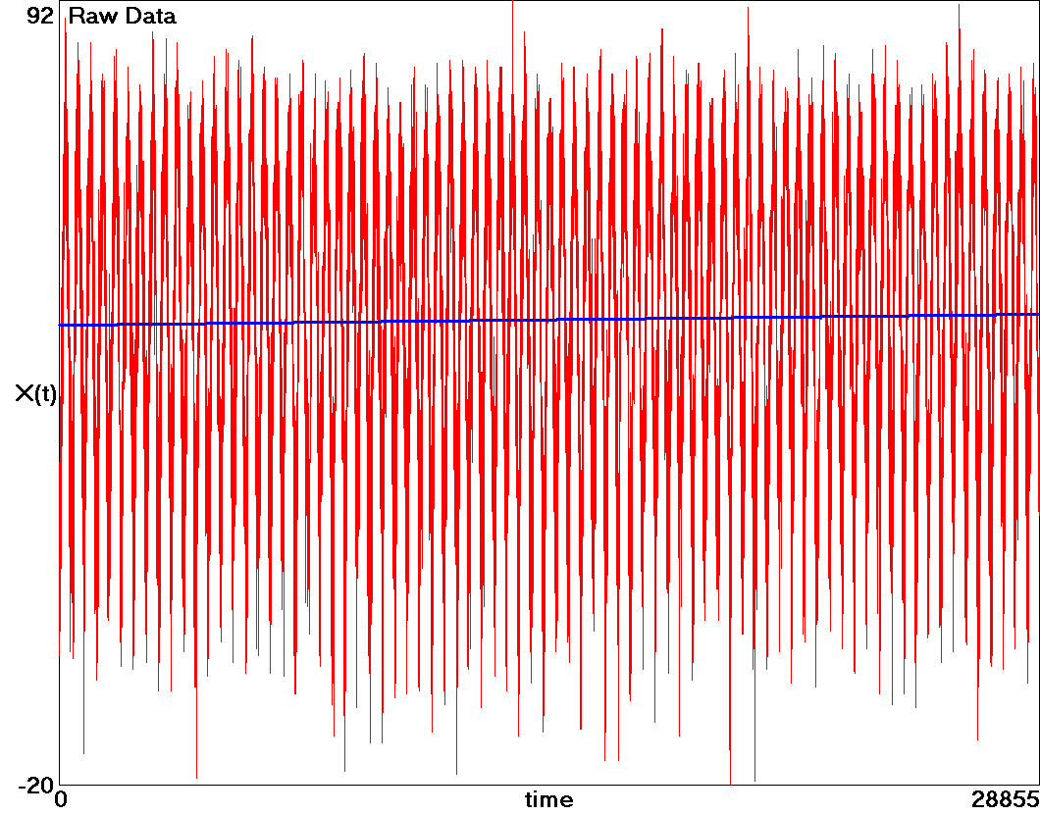

The annual cycle is clearly evident with extreme values of -20ºF on January 18, 1994 and +92ºF on July 10, 1976. Also shown (in blue) is a simple linear least-squares fit to the data, which shows that the average temperature increased from 45.6ºF to 47.2ºF over the 79-year period. This is a 1.6ºF increase with an uncertainty of ±0.4ºF, hereafter represented as +1.6 ± 0.4ºF. Thus there is strong evidence that Madison, WI has warmed by almost 2ºF during my lifetime with a significance of about four standard deviations (99.99% certainty). By comparison, the standard deviation of the entire data set is about 21ºF, an order of magnitude greater than the warming.

The importance of beginning and ending at an extremum can be illustrated by using data from January 1, 1940 to December 31, 2018 (not shown). In that case, the linear regression gives a warming of +1.9 ± 0.4ºF, which is 0.3ºdifferent from the correct value, although within one standard deviation of it. Regression analysis is particularly sensitive to data at the beginning and end of the record and much less so for data near the middle.

It is also interesting to ask whether the warming trend is accelerating or decelerating. The most straightforward way to address that question is to fit a second-degree polynomial (a parabola) to the data and look at the sign of the quadratic term. Such a fit gives the same +1.6 ± 0.4ºF temperature rise but with a positive second derivative of +0.0014ºF/year² with about three standard deviations of certainty indicating that the rate of warming is increasing.

One can go a step further and fit the data to a third-degree polynomial, and the cubic term is also positive with a barely statistically significant third derivative of +0.00005ºF/year³ indicating that the rate of warming is accelerating in addition to increasing as would be the case if the mean temperature were climbing exponentially, all of whose derivatives are positive.

Perhaps a more transparent way to answer the question is to look at the linear trend separately for the first 40 years and for the last 40 years. This gives a one-year overlap, but it is important to use a whole number of years as previously mentioned. The result is that the first 40 years actually shows a cooling trend of -2.3 ± 0.6ºF, while the last 40 years shows a warming trend of +2.6 ± 0.6ºF. Thus there is good evidence that the rate of warming is increasing.

Yet another way to view changes in the trend is to plot a moving average (a window) of the data. The following plot shows the result for a 10-year (3652-day) window of the moving average (in red) along with a linear regression (in blue):

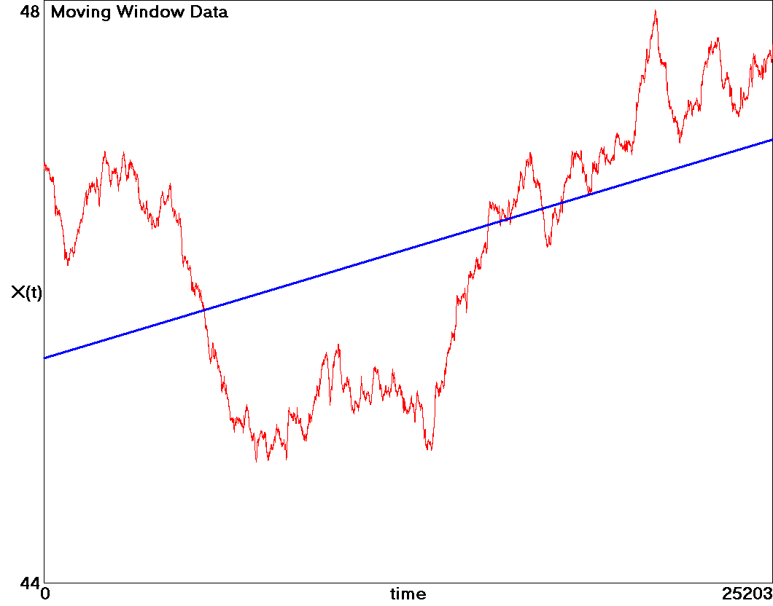
The windowing removes five years at the beginning of the record and five years at the end with each data point representing the midpoint of the window. Thus the windowed data shows roughly the years 1945 – 2013. A remarkable feature is the cold period (temperature well below the trend line) lasting from about 1960 until 1987 after which a rapid warming in excess of the trend began that is yet to abate.

To assess climate variability, it is useful to remove the yearly cycle which is approximately sinusoidal. The first step is to detrend the data by subtracting from each raw data point the prediction of the linear fit shown as the blue line in the first graph, giving a time series with zero mean and no long-term trend. The detrended data is then fit to a sine wave with a period of 28855/79 = 365.25 days by discrete Fourier analysis as shown in the following plot:

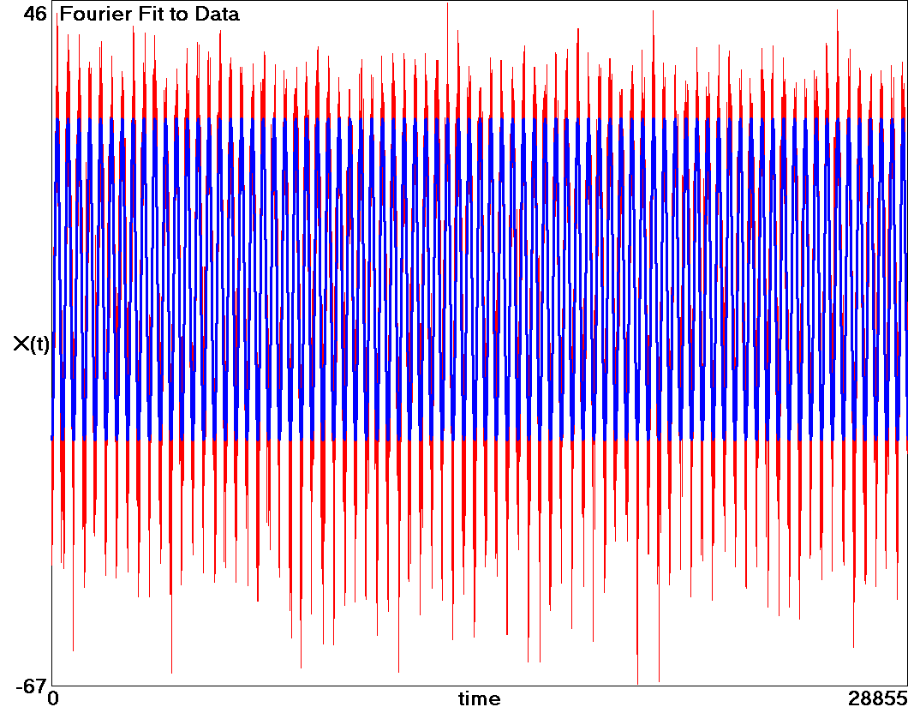

This Fourier component (shown in blue) has an amplitude of ± 26.5ºF. Thus there is about a 53ºF swing in temperature as a result of the annual cycle. Since the data begins and ends at an extremum (the coldest day on average), the Fourier analysis lacks a sine term, and thus the blue curve is given by X(t) = -26.5 cos(2πt/365.25).

This annual cycle is not perfectly sinusoidal, but it has a second harmonic (a period of 182.625 days) with an amplitude of ± 1.7ºF and a third harmonic (a period of 121.75 days) with an amplitude of ± 0.8ºF. These small corrections do not qualitatively change any of the conclusions and are thus ignored.

Then as before, the data is further detrended by subtracting the blue curve (a sine wave) from the red one to obtain the following seasonally adjusted data set:

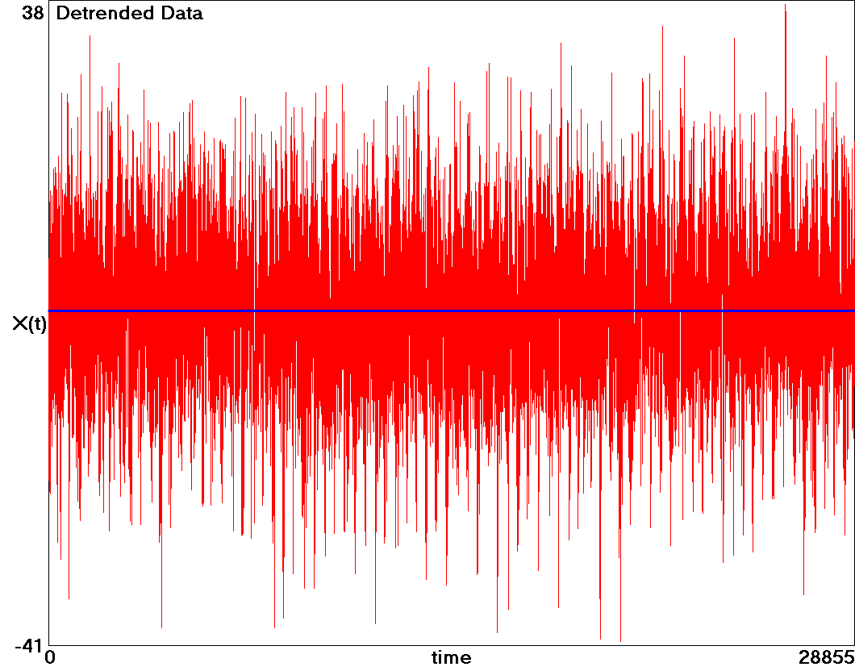

You might wonder whether the conclusions would change if the seasonality were removed before the linear detrending of the data. That can be answered by subtracting the mean from the raw data, then fitting a sine wave to the result and subtracting its value from each data point, and then doing a linear regression. The result is substantially the same but with a smaller uncertainty of +1.6 ± 0.2ºF, and so perhaps this would have been a better way to analyze the data.

We are now if a position to ask whether the variability in temperature has increased or decreased over the period and by how much. The simplest definition of variability is the square of the deviation of each data point from the mean, which is now essentially zero as a result of the detrending. This is called the variance or second moment of the data and is usually calculated as an average over the entire data set. However, our interest is in how the variance has changed over time, and so we plot the variance of each data point, basically just the square of each point in the above plot, to obtain the following plot:

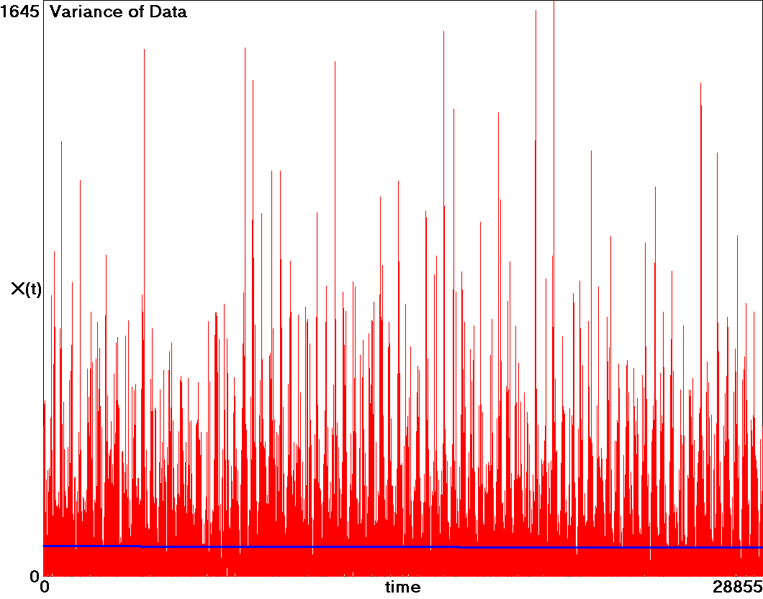

The blue line is a linear fit to the data and shows a change of -5.4 ± 3.1 %. The average standard deviation of the seasonally-detrended data is about 9ºF. Thus the evidence indicates a decrease in temperature variability for Madison over the past 79 years with almost two standard deviations (95%) of certainty, in contradiction to the often-heard claims.

It is also of interest to examine higher moments of the data. In particular, the odd moments of the data exhibit the hot/cold asymmetry. Such a plot for the third moment of the data (called the skewness when it is normalized by the cube of the standard deviation to make it a dimensionless quantity) is shown below:

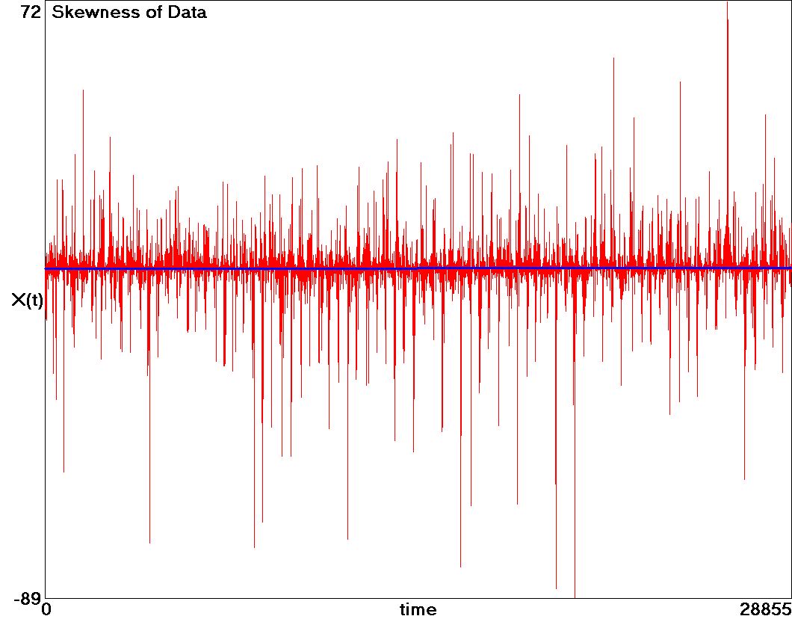

The skewness, which is relatively small, has changed from -0.26 to -0.04 (a change of +0.22 ± 0.10) over the past 79 years, which means that this asymmetry has almost completely disappeared over the years. Recent years have shown more extreme hot days and fewer extreme cold ones than in the past, so that the distribution is now nearly symmetric about the mean. Said differently, the winters have warmed more than the summers.

Another claim often heard is that climate change will lead to more extreme events, and that claim can be tested with this data set. One measure of extreme events is the fourth moment of the data (the fourth power of the deviation of each data point from the mean) as shown below:

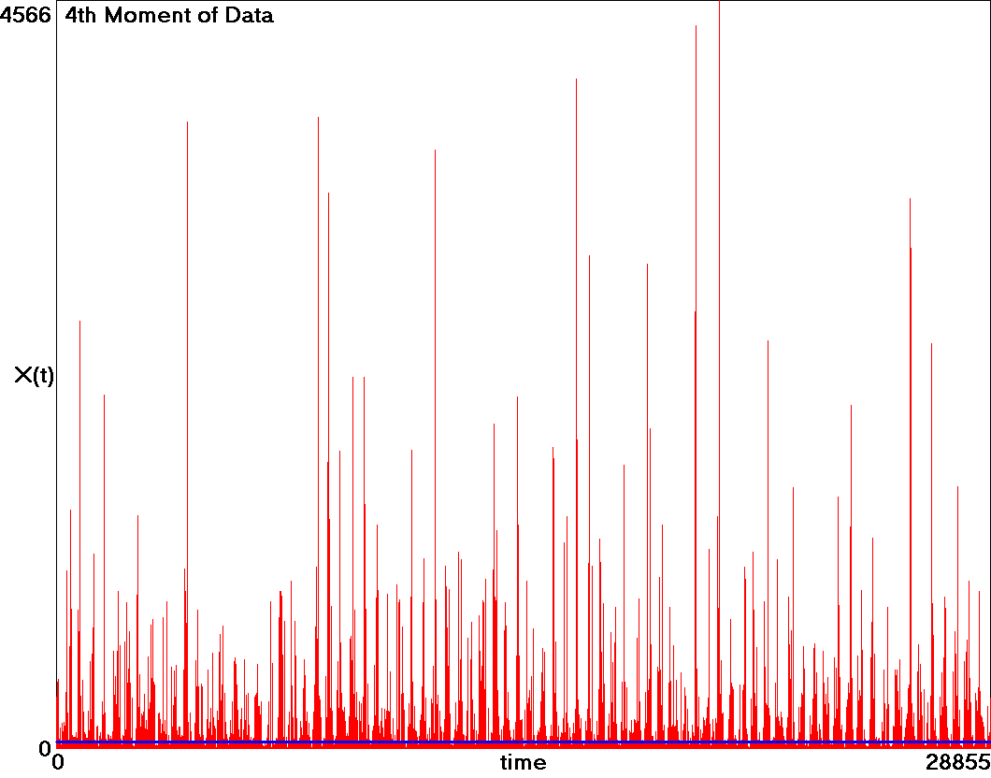

Temperature extremes that occur only a few times per decade are clearly evident in the data. The blue line shows a linear fit to the data, and it shows a change of -1.7 ± 8 % over the period. This small decrease is not statistically significant, but any change in temperature extremes is at most the order of 8%. One could also look at higher even moments of the data to put yet more emphasis on the most extreme events (those far out in the tail of the distribution), but the statistics become significantly worse so that nothing useful is learned.

Furthermore, most of this decrease in the fourth moment is a consequence of the decrease in the variance of the data as shown previously. Said differently, anything that narrows the overall distribution will likely also reduce the number and size of the data points in the tail of the distribution. Thus a more revealing measure is the kurtosis of the data, which is the fourth moment of the data divided by the square of the second moment, and this dimensionless quantity is shown in the following plot:

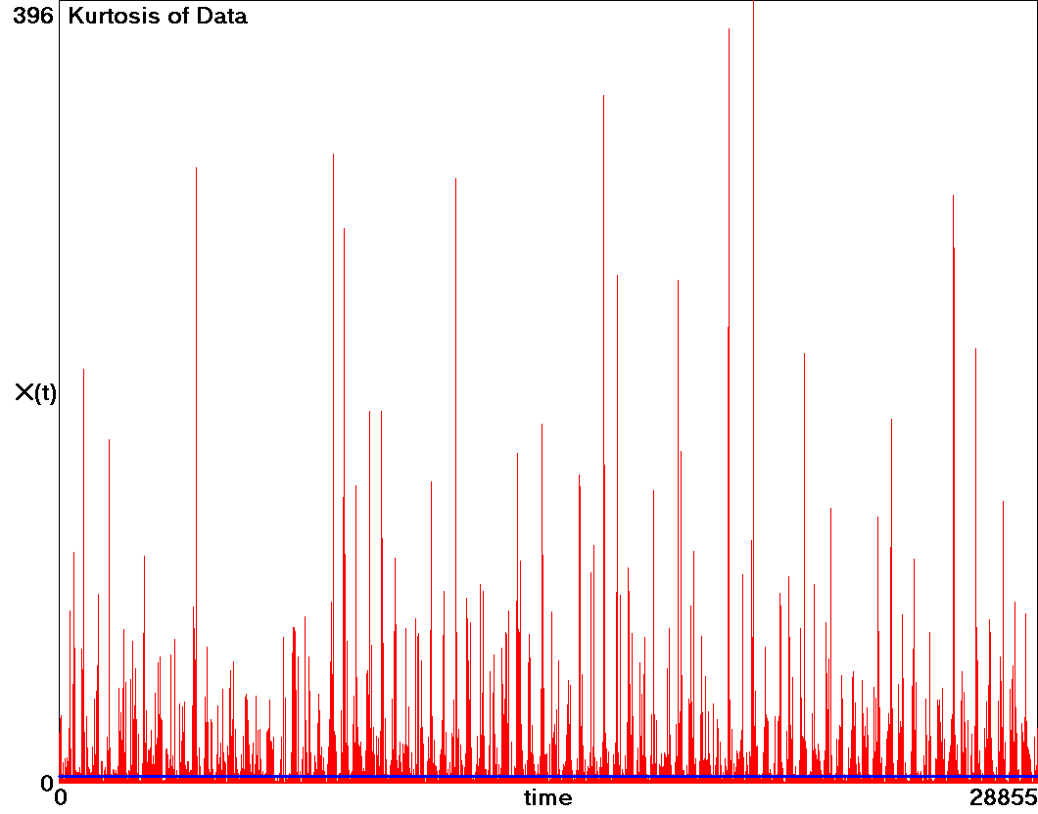

The blue line is a linear least squares fit and shows an increase of +8.8 ± 8.5 %, which is not statistically significant. Interestingly, the kurtosis over the period has increased from about 3.3 to about 3.6, both are which are larger than the value of 3.0 expected for a normal (Gaussian) distribution. Thus the temperature distribution is slightly leptokurtic (fat-tailed) and is becoming increasingly more so but not by a statistically significant amount.

In summary, the temperature data shows the warming trend that is now well documented and that it is increasing, but it does not support the claim that variability and extreme events are more common than in the past. Indeed, there has been a statistically significant decrease in temperature variability over the past 79 years. This may be a consequence of the gradual warming that has reduced the number and severity of cold spells while not greatly exacerbating the heat waves. The results are summarized in the following table:

Madison, WI temperature (1940 – 2019)
Change in temperature: +1.6 ± 0.4ºF
Standard deviation of temperature: 21ºF
Percent change in variance: -5.4 ± 3.1 %
Percent change in fourth moment: -1.7 ± 8 %
Percent change in kurtosis: +8.8 ± 8.5 %

One can also ask all the same questions with regard to precipitation. For this purpose, 79 years of daily precipitation data in inches for the same period from the Madison, WI airport was downloaded and analyzed. Snowfall was melted and converted to the equivalent inches of rain. There were many days characterized by a trace of precipitation, and these were set to zero. The raw data is shown below:

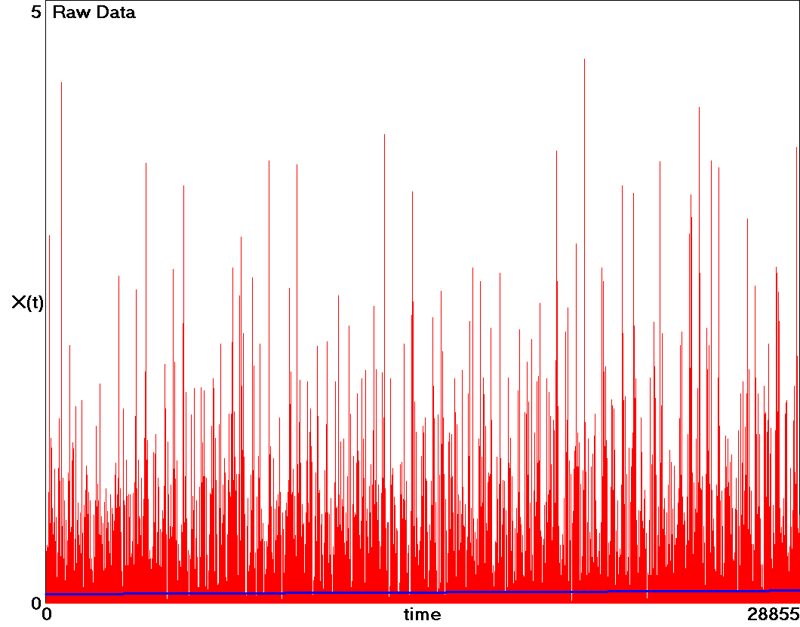

The maximum rainfall was 4.51 inches on June 17, 1996, and most days had little or no precipitation. The linear fit in blue shows that the average daily precipitation increased by +38.9 ± 7.3 % (from 0.075 inches/day to 0.104 inches/day) over the 79 year period. Thus, without question (five standard deviations of certainty), Madison has become significantly wetter over the years, and most of that increase has occurred in the recent past (+31.9 ± 9.8% in the most recent 40 years versus +9.1 ± 9.1 % in the first 40 years).

The precipitation data was subjected to the same analysis as previously described for the temperature data. Rather than show all the individual graphs, the results are summarized below:
Madison, WI Precipitation (1940 – 2019)
Percent change in precipitation: +38.9 ± 7.3 %
Standard deviation of precipitation: 0.27 inches
Percent change in variance: +80.9 ± 19.6 %
Percent change in fourth moment: +146.1 ± 73.1 %
Percent change in kurtosis: -40.0 ± 37.8 %

At first sight, it appears that there has been a large increase in rainfall variability (variance) and extreme rain events (fourth moment). However, essentially all the increase is a simple consequence of the increasing mean precipitation. Roughly speaking, if the mean increases by 40% (as it did), the variance should increase by 80% and the fourth moment should increase by 160% if the shape of the probability distribution function remains unchanged, and that is approximately what happened. In fact, the kurtosis, which normalizes the fourth moment of the distribution by the fourth power of the standard deviation and serves of one measure of extreme events shows a slight barely significant decrease. Thus the increase in extreme rainfall events is a simple and expected consequence of the generally wetter climate.

In summary, Madison, has become slightly warmer and significantly wetter over the past 79 years, and these trends are accelerating. This change has not led to more temperature variability, but it has led to more extreme rainfall events, but no more than one would expect for a generally wetter climate. Thus there is some support for the claim that climate change is causing more variability in the weather, but the effect is mostly in the amount of rainfall and is largely absent in or even contradicted by the deviations of temperature from the mean.

To see whether these results are robust, I performed the same analysis on temperature and precipitation data for the same period from the Milwaukee, WI airport (MKE), which is 100 km east of Madison and whose climate might be somewhat different because it is on the western shore of Lake Michigan. The results are summarized below:

Milwaukee, WI temperature (1940 – 2019)
Change in temperature: +3.1 ± 0.4ºF
Standard deviation of temperature: 20ºF
Percent change in variance: -8.6 ± 3.1 %
Percent change in fourth moment: -10.2 ± 8.2 %
Percent change in kurtosis: +6.4 ± 9.0 %

Milwaukee, WI Precipitation (1940 – 2019)
Percent change in precipitation: +26.3 ± 6.7 %
Standard deviation of precipitation: 0.26 inches
Percent change in variance: +41.9 ± 20.2 %
Percent change in fourth moment: +93.0 ± 145.5 %
Percent change in kurtosis: -16.2 ± 89.5 %

Apparently the warming has been greater in Milwaukee than in Madison (about 3ºF versus 1.6ºF) and the increase in precipitation less (26% versus 39%), but there is no evidence for increased variability or extreme events beyond what would be expected from the increased mean precipitation.

One could also examine how the trends differ for each of the four seasons and analyze other quantities such as barometric pressure and wind speed, which might be better surrogates for storminess. For the present, I am content to accept the claim that climate variability has increased, at least in regard to certain weather variables such as rainfall, but not more than would be expected from the increase in the mean. Particularly worrisome is the accelerating rate of increase for both the mean temperature and rainfall. Of course, these results only apply to southern Wisconsin, and there could be places in the world where the conclusions are quite different.

Acknowledgment: I am grateful to John Young for pointing me to the data used here and for discussing the meaning and interpretation of the results.

