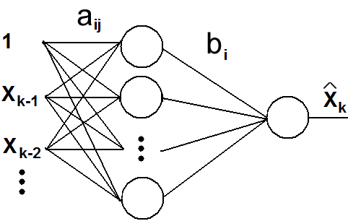

FIG. 1: Single Layer, Feed-Forward Neural Network

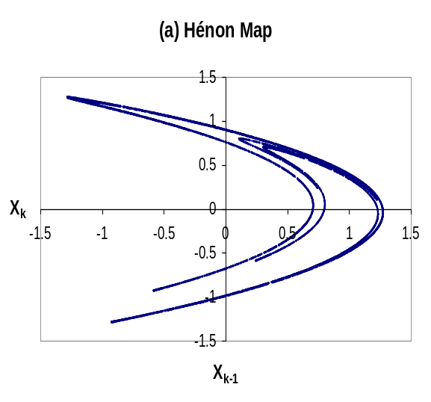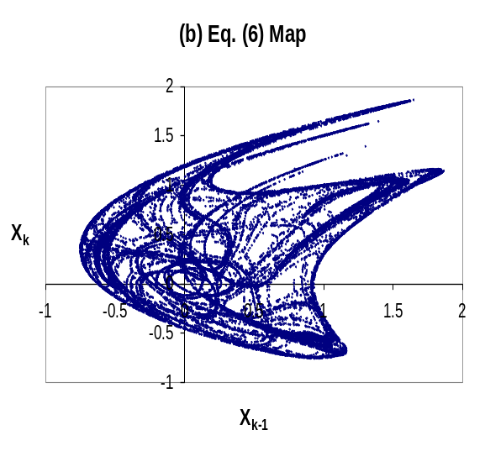
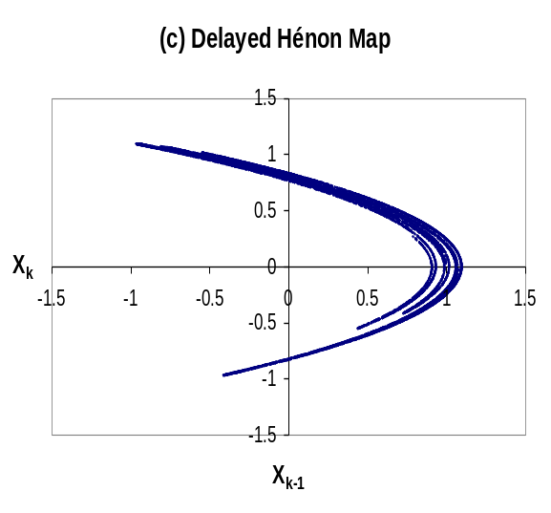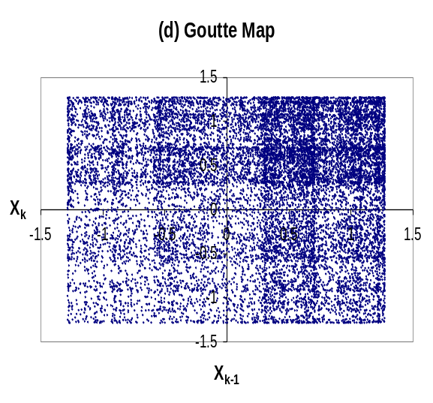
FIG. 2: Strange Attractors of maps studied

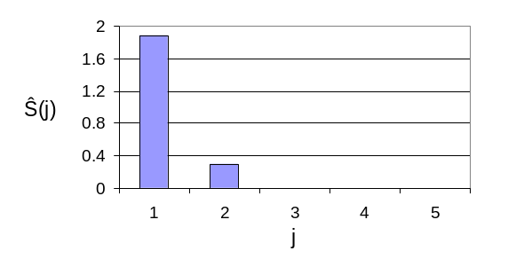
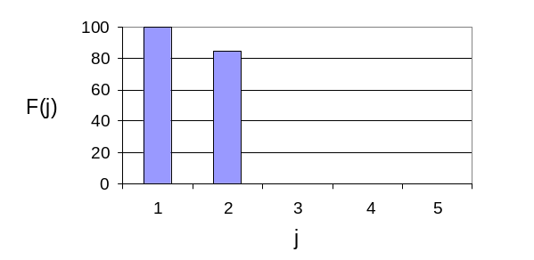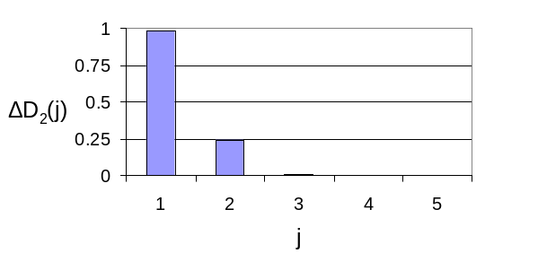
FIG. 3: Embedding Calculations for simple Hénon map using (a) Neural Network Sensitivities (b) False Nearest Neighbors (c) Correlation Dimension

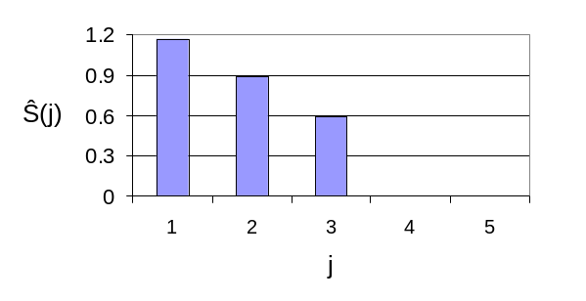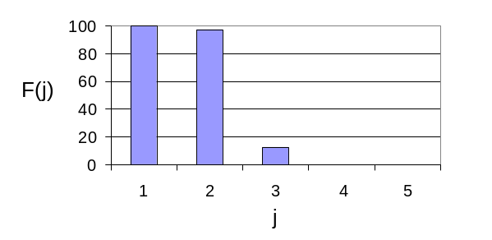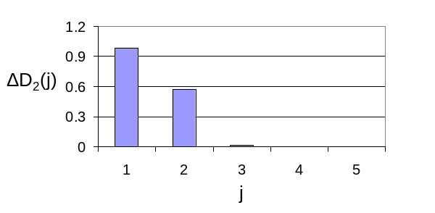
FIG. 4: Embedding Calculations for Eq. (6) map using (a) Neural Network Sensitivities (b) False Nearest Neighbors (c) Correlation Dimension

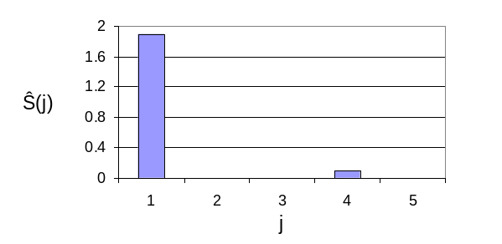
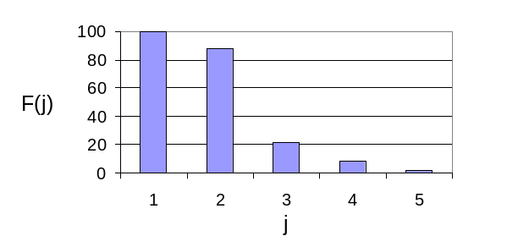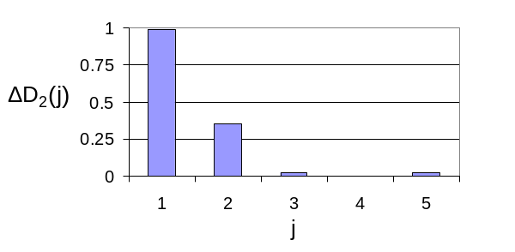

FIG. 5: Embedding Calculations for delayed Hénon map using (a) Neural Network Sensitivities (b) False Nearest Neighbors (c) Correlation Dimension

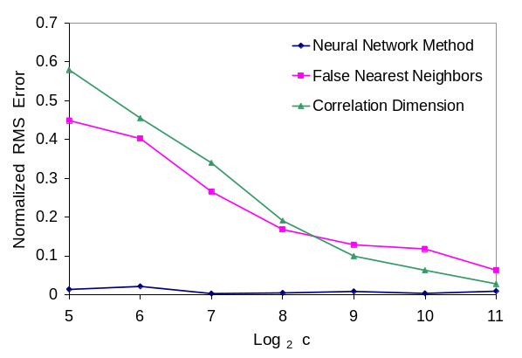
FIG. 7: Methods with varying c

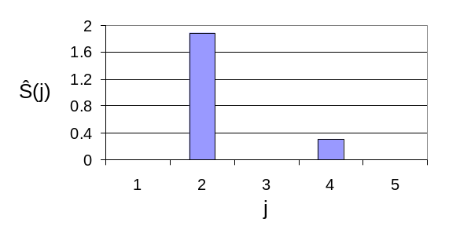
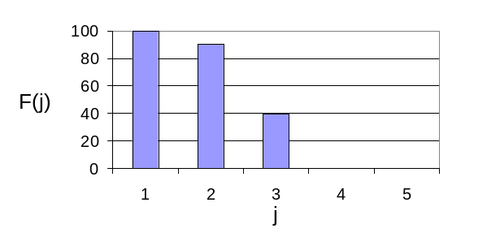
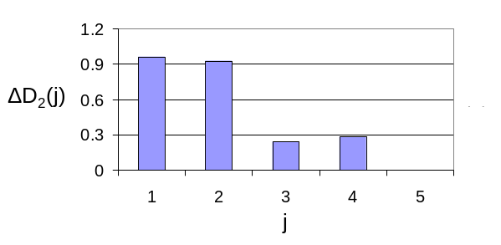

FIG. 6: Embedding Calculations for Goutte map using (a) Neural Network Sensitivities (b) False Nearest Neighbors (c) Correlation Dimension

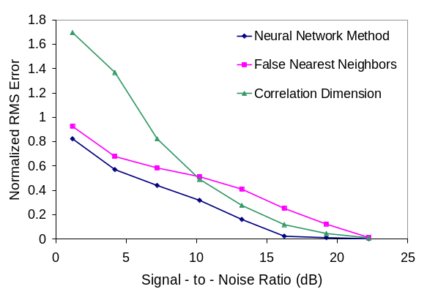
FIG. 8: Methods with varying Noise

